CSD310 Module 10, Milestone #2 (Group 1)

Austin Moore, Joseph Smith, Jon Green, Taylor King

Bacchus Winery Study

**Revised ERD:**

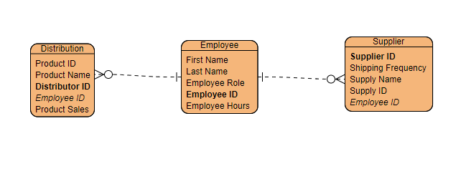

Data Display from Tables:

